**Course:** ENSF 337 – Fall 2020

**Lab #:** Lab 5

**Instructor:** M. Moussavi

**Student Name:** Quentin Jennings

**Lab Section:** B03

**Submission Date:** 2020-10-18

**Exercise A and B:**

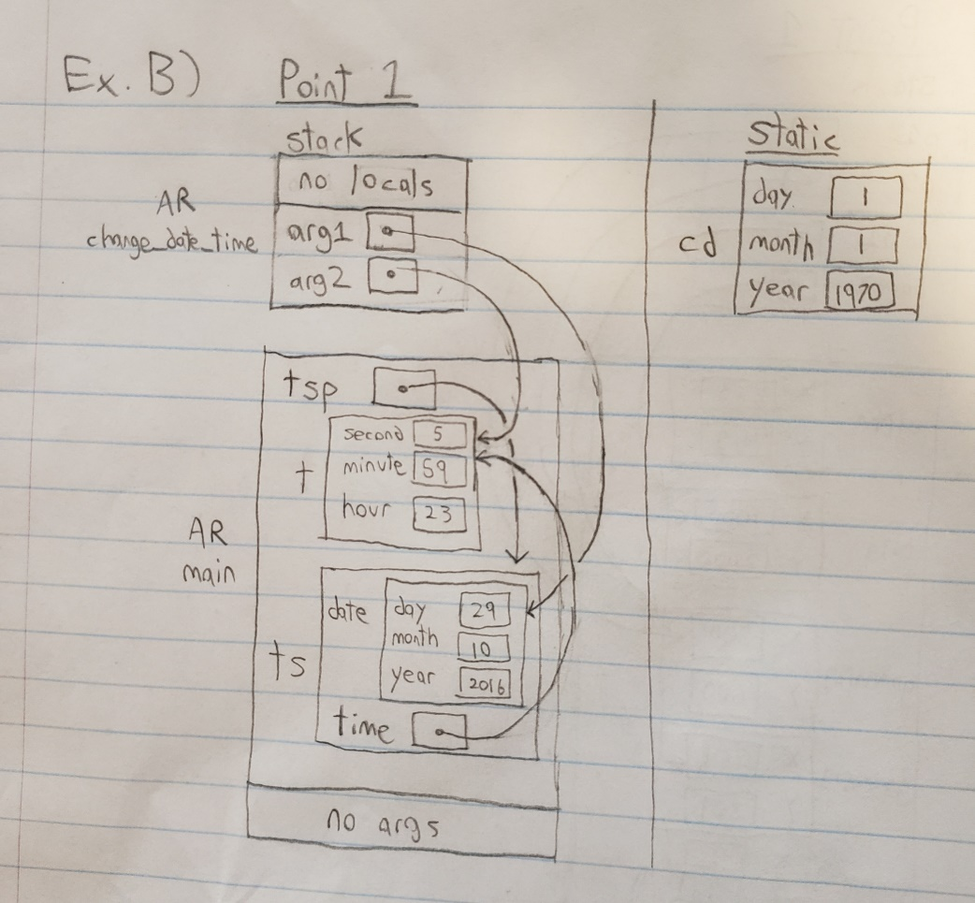

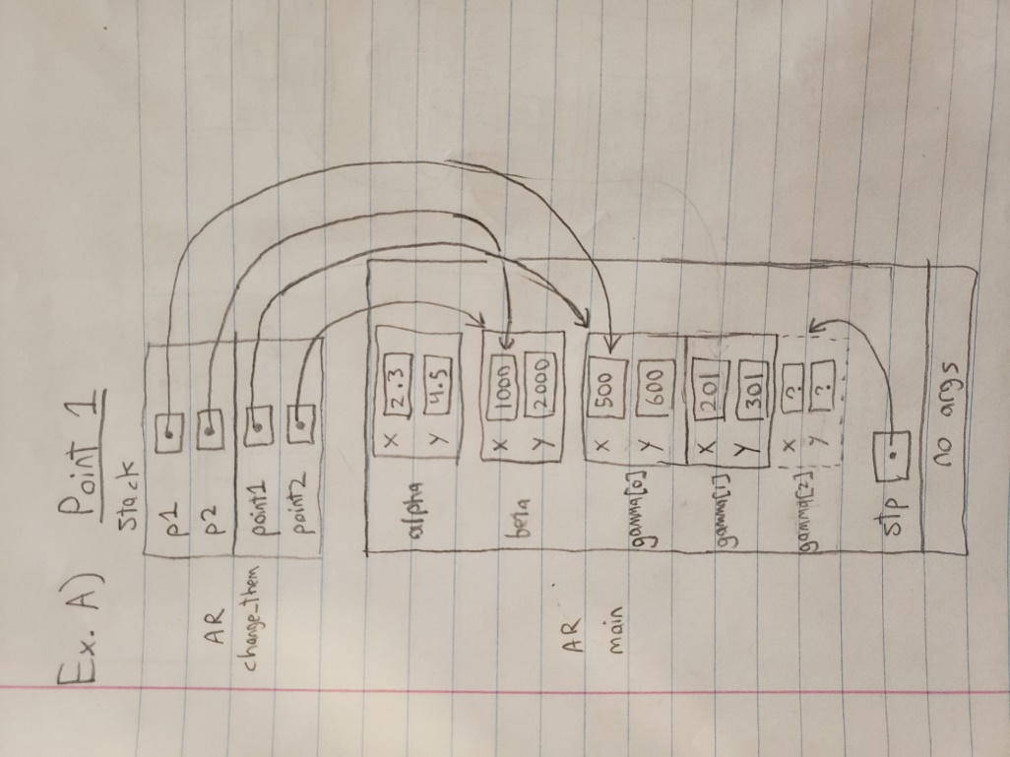

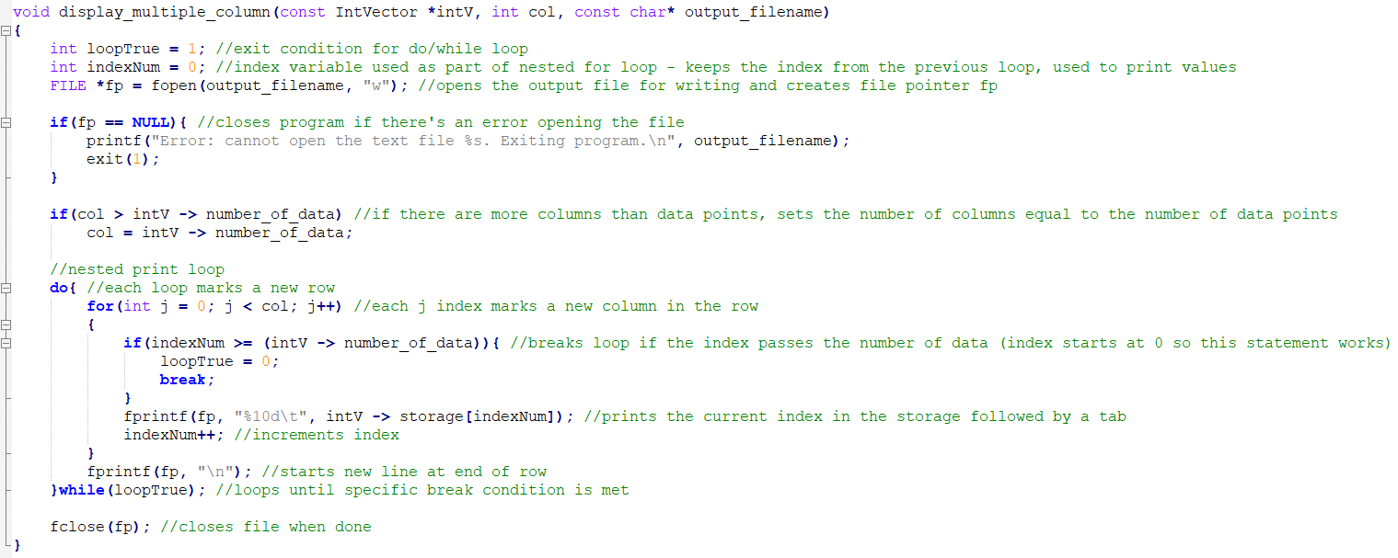**Exercise D display_multiple_column:**

**Exercise D lab5exe_D_output.txt:**

234 678 999 234

33 22 99 222

45 56 44 77

92 91 81 73

19 18 17 666

555 1 3 6

**Exercise E Output:**

Display the values in alpha, and beta:

A1 <2.30, 4.50, 56.00>

B1 <25.90, 30.00, 97.00>

Display the values in *stp:

A1 <2.30, 4.50, 56.00>

Display the values in gamma after calling mid_point function.Expected result is: M1 <14.10, 17.25, 76.50>

The actual result of calling mid_point function is:

M1 <14.10, 17.25, 76.50>

Display the values in *stp, and beta after calling swap function.Expected to be:

B1 <25.90, 30.00, 97.00>

A1 <2.30, 4.50, 56.00>

The actual result of calling swap function is:

B1 <25.90, 30.00, 97.00>

A1 <2.30, 4.50, 56.00>

The distance between alpha and beta is: 53.74. (Expected to be: 53.74)

The distance between gamma and beta is: 26.87. (Expected to be: 26.87)

**Exercise E Source Code: (lab5exE.h)**

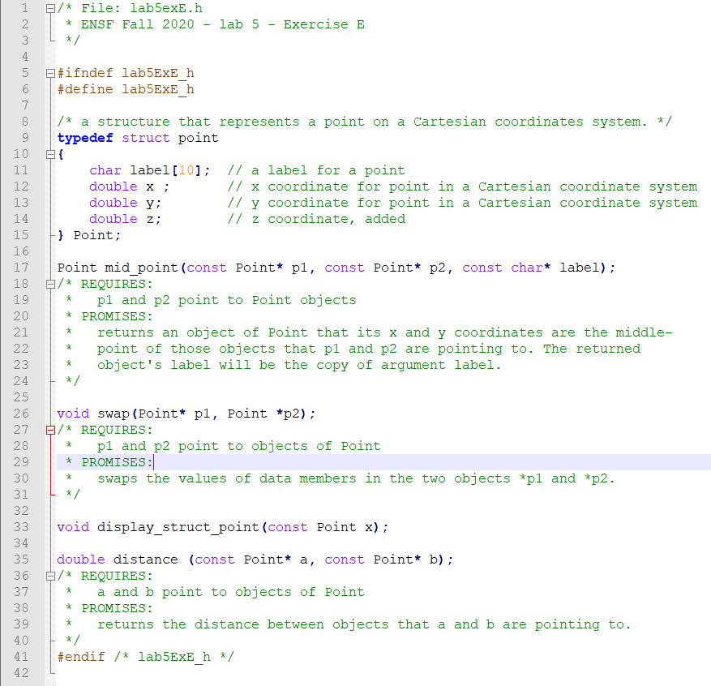

**Exercise E Source Code: (lab5exE.c)**

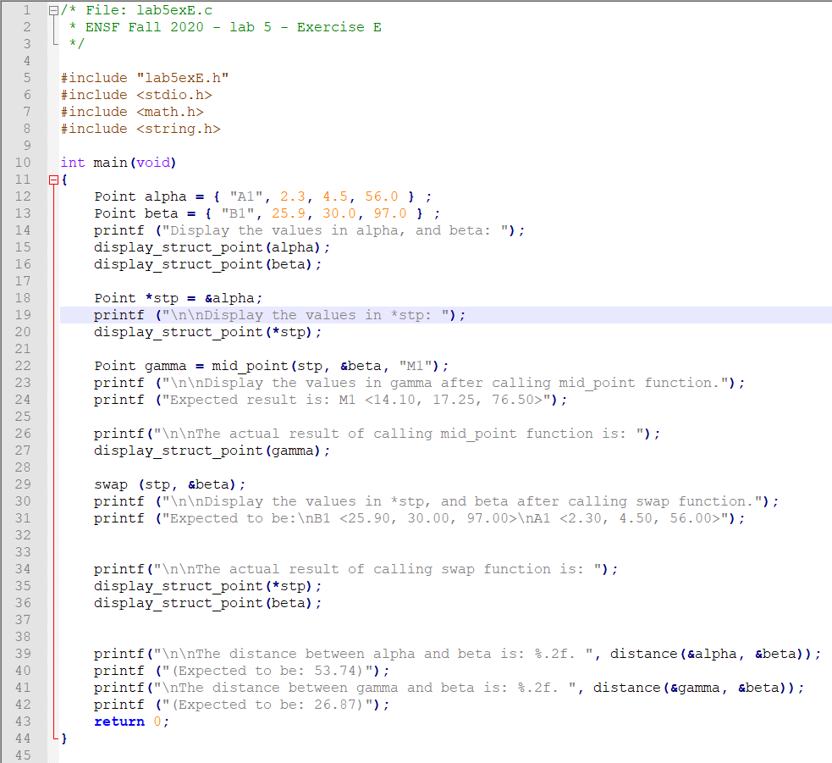

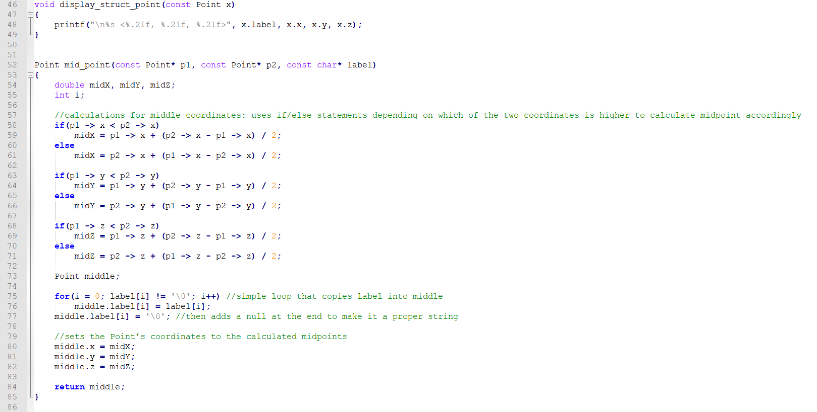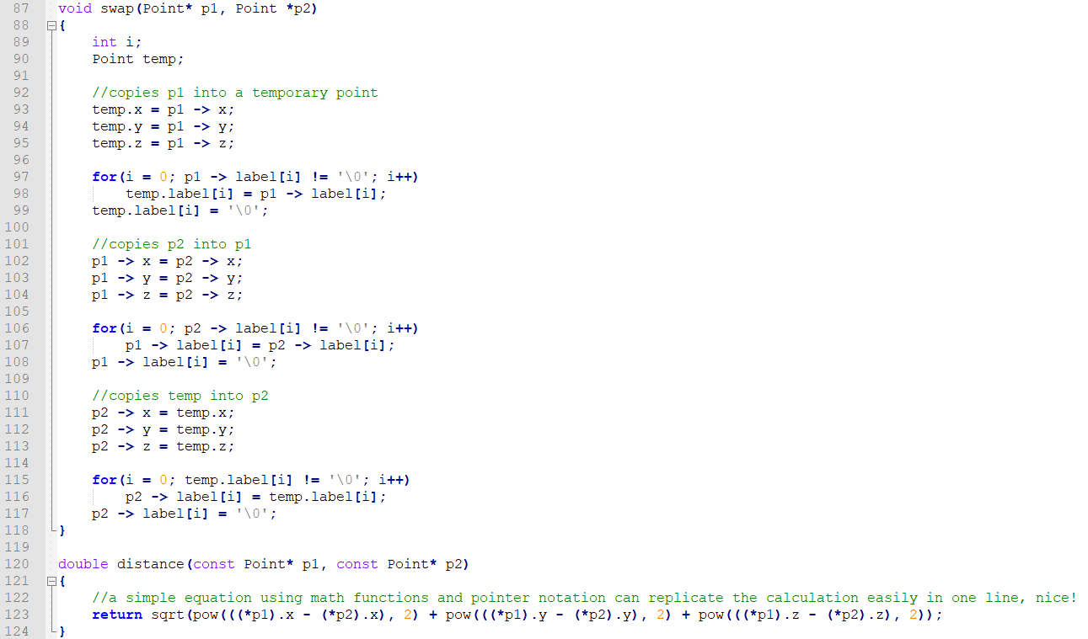

**Exercise F Output:**

Array of Points contains:

struct_array[0]: A9 <700.00, 840.00, 1050.00>

struct_array[1]: z8 <300.00, 360.00, 450.00>

struct_array[2]: B7 <999.00, 1200.00, 1500.00>

struct_array[3]: y6 <599.00, 719.00, 900.00>

struct_array[4]: C5 <198.00, 239.00, 299.00>

struct_array[5]: x4 <898.00, 1079.00, 1349.00>

struct_array[6]: D3 <497.00, 598.00, 749.00>

struct_array[7]: w2 <97.00, 118.00, 149.00>

struct_array[8]: E1 <796.00, 958.00, 1198.00>

struct_array[9]: v0 <396.00, 477.00, 598.00>

Test the search function

Found: struct_array[9] contains v0

Found: struct_array[8] contains E1

Found: struct_array[4] contains C5

Found: struct_array[2] contains B7

Found: struct_array[0] contains A9

struct_array doesn't have label: E11.

struct_array doesn't have label: M1.

Testing the reverse function:

The reversed array is:

struct_array[0]: v0 <396.00, 477.00, 598.00>

struct_array[1]: E1 <796.00, 958.00, 1198.00>

struct_array[2]: w2 <97.00, 118.00, 149.00>

struct_array[3]: D3 <497.00, 598.00, 749.00>

struct_array[4]: x4 <898.00, 1079.00, 1349.00>

struct_array[5]: C5 <198.00, 239.00, 299.00>

struct_array[6]: y6 <599.00, 719.00, 900.00>

struct_array[7]: B7 <999.00, 1200.00, 1500.00>

struct_array[8]: z8 <300.00, 360.00, 450.00>

struct_array[9]: A9 <700.00, 840.00, 1050.00>

**Exercise F Source Code:** (rest of code is same, only asked to make the 2 functions)

